SURAJ KUMAR
1NT19IS167

Hybrid Application Development

Activity Life Cycle

JAVA Code:

package com.example.activitylifecycle167;
import androidx.appcompat.app.AppCompatActivity;
import android.os.Bundle;
import android.widget.Toast;
public class MainActivity extends AppCompatActivity {
@Override
protected void onCreate(Bundle savedInstanceState) {
super.onCreate(savedInstanceState);
setContentView(R.layout.activity_main);
Toast.makeText(this,"ACTIVITY CREATED",Toast.LENGTH_SHORT).show();
}
@Override
protected void onStart() {
super.onStart();
Toast.makeText(this,"ACTIVITY STARTED",Toast.LENGTH_SHORT).show();
}
@Override
protected void onStop() {
super.onStop();
Toast.makeText(this,"ACTIVITY STOPPED",Toast.LENGTH_SHORT).show();
}
@Override
protected void onDestroy() {
super.onDestroy();
Toast.makeText(this,"ACTIVITY DESTROYED",Toast.LENGTH_SHORT).show();
}
@Override
protected void onPause() {
super.onPause();
Toast.makeText(this,"ACTIVITY PAUSED",Toast.LENGTH_SHORT).show();
}
@Override
protected void onResume() {
super.onResume();
Toast.makeText(this,"ACTIVITY RESUMED",Toast.LENGTH_SHORT).show();
}
}

XML Code:

<?xml version="1.0" encoding="utf-8"?>
<androidx.constraintlayout.widget.ConstraintLayout xmlns:android="http://schemas.android.com/apk/res/android"
xmlns:app="http://schemas.android.com/apk/res-auto"
xmlns:tools="http://schemas.android.com/tools"
android:layout_width="match_parent"
android:layout_height="match_parent"
tools:context=".MainActivity">
<TextView
android:layout_width="wrap_content"
android:layout_height="wrap_content"
android:text="Hello World!"
android:textSize="48sp"
app:layout_constraintBottom_toBottomOf="parent"
app:layout_constraintEnd_toEndOf="parent"
app:layout_constraintStart_toStartOf="parent"
app:layout_constraintTop_toTopOf="parent" />
</androidx.constraintlayout.widget.ConstraintLayout>

Output:

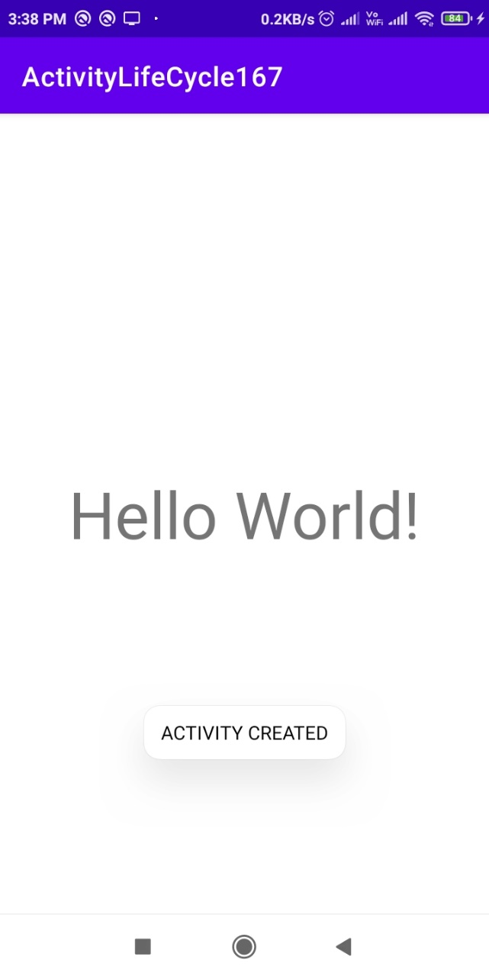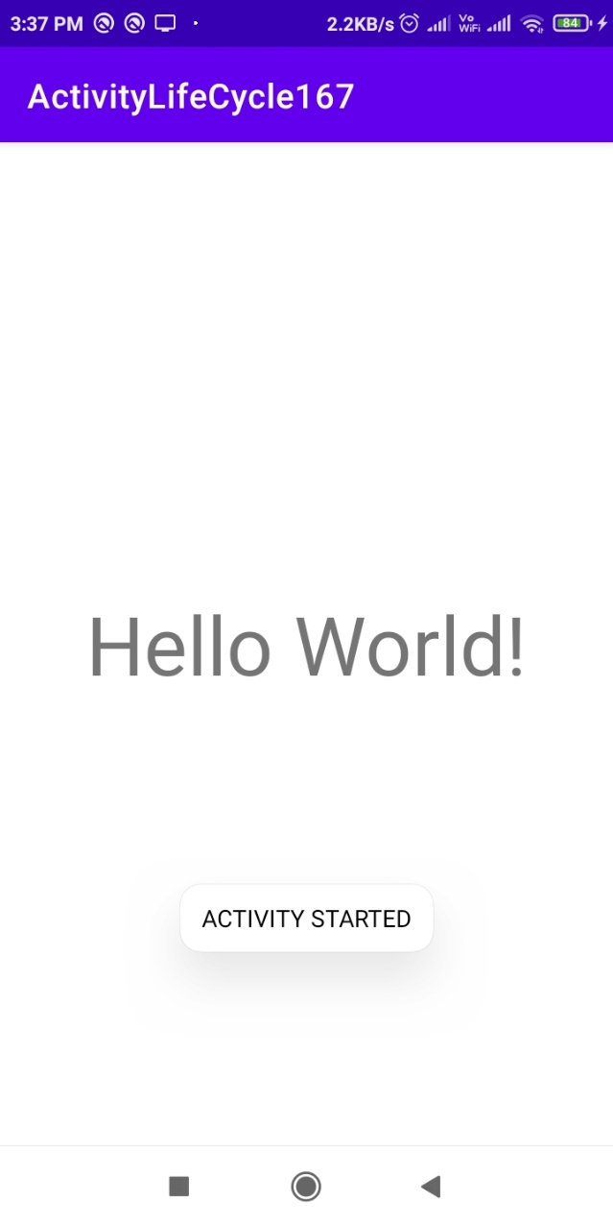

Activity Created Activity Started
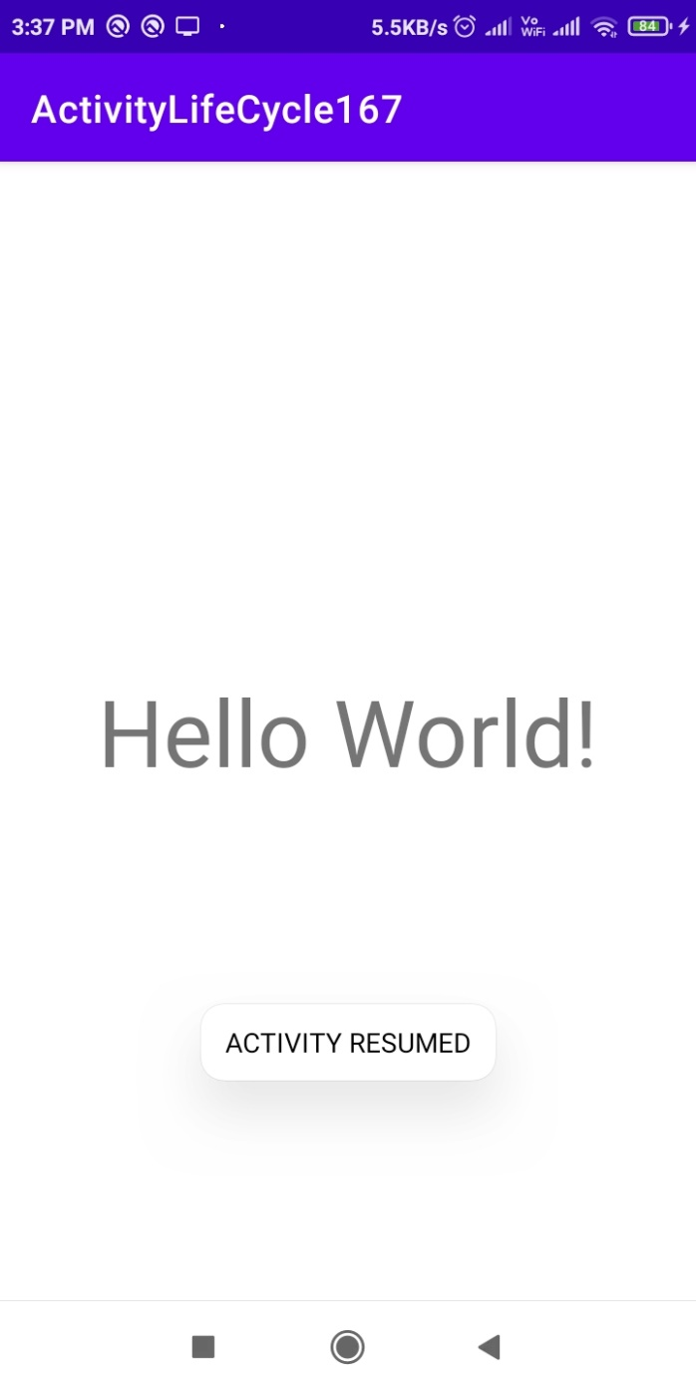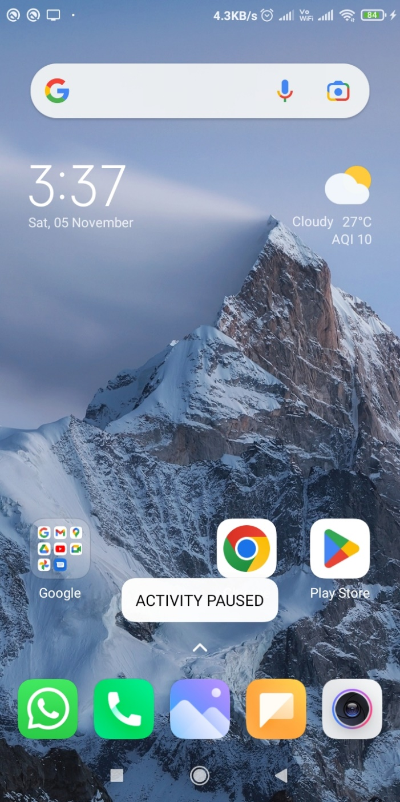

Activity Resumed Activity Paused
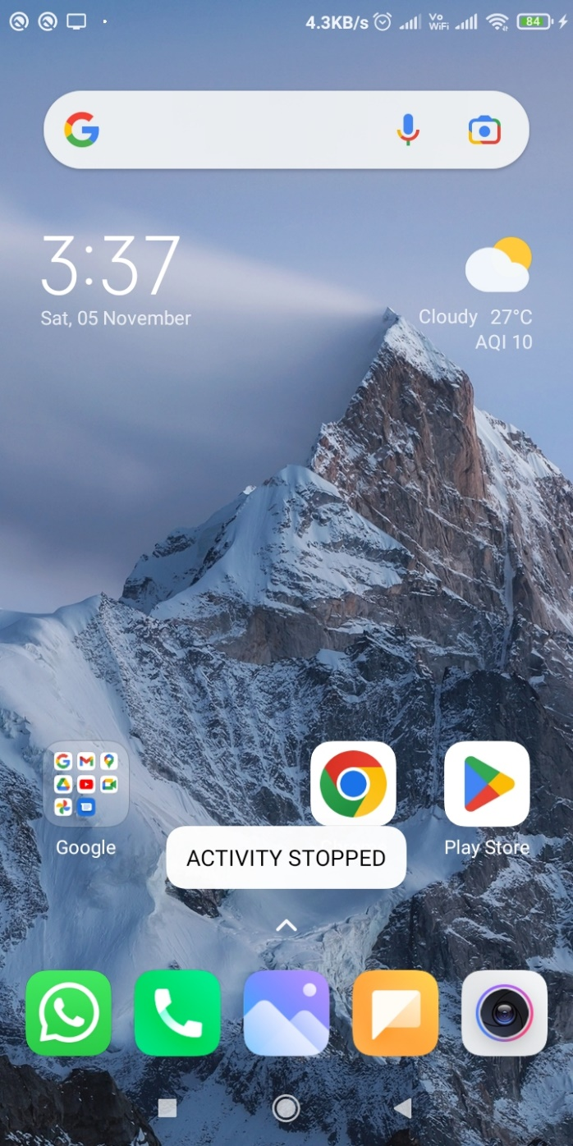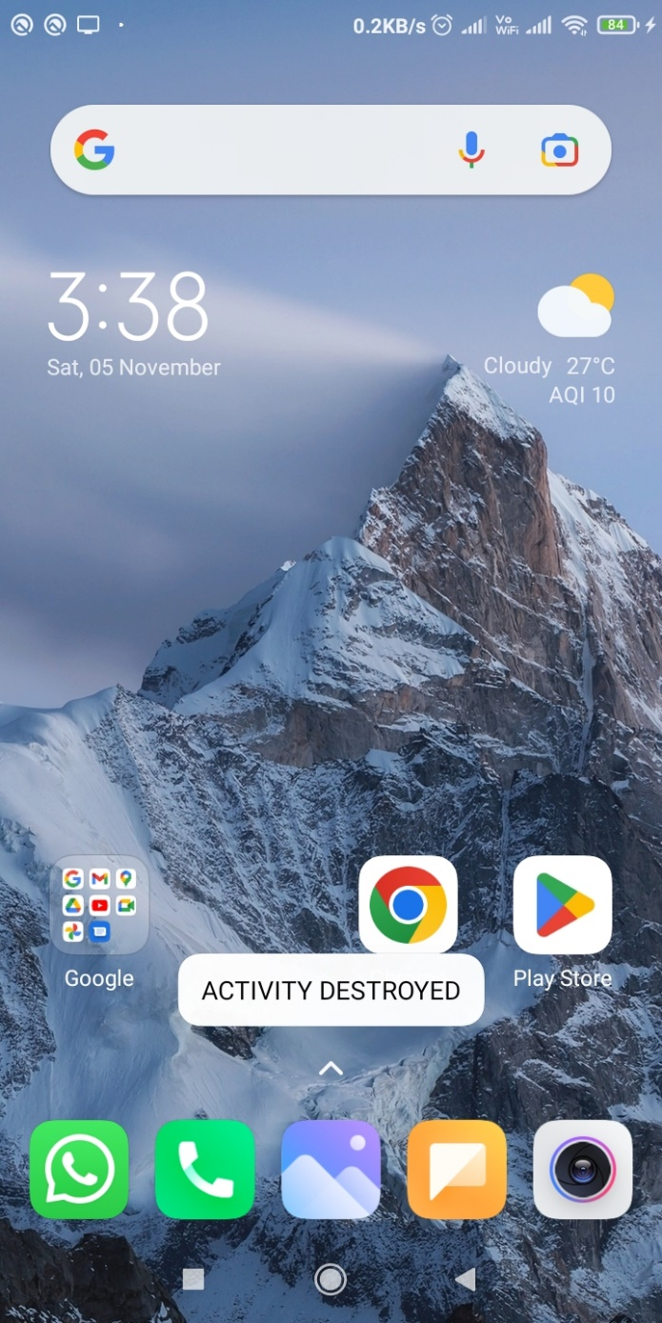

Activity Stopped Activity Destroyed

